**Are you looking for a new opportunity to develop your career?**

FULL-TIME

PERMANENT

**BIM MANAGER**

**Make a difference – Shape not only your future, but the environment around you.**

We aim to provide a work environment where you can unleash your creativity, innovation and skills while doing what you are passionate about every day.

**ABOUT US**

EDC was established in 2002 and thanks to our quality-driven approach to engineering and early-adopter ethos with new technology, we have grown during a period when most companies in this sector have struggled. We have continued to increase our workload and deliver quality, innovative engineering.

As pioneers in the design of low-energy, high- performance buildings and systems, EDC fully supports the importance placed on sustainability and welcomes the challenges this presents. We are first BIM Level 2 Certified Consultancy in the UK and Ireland and deliver projects from our three offices in Ireland – Cork, Mid-West & Dublin and our UK office based in London. EDC has also seen significant recent expansion overseas in the African Market.

**OUR MISSION**

At EDC, our mission is to be progressive for our clients and our employees. We embrace innovation to drive efficiency in construction by leading the way. We cultivate an open, dynamic internal culture where good people and good ideas will always be heard.

EDC is a truly progressive consulting engineering firm. We are industry innovators, striving to deliver the most striking and dynamic work possible for our clients. EDC is recognised throughout the industry as being at the forefront of sustainable design and as a consultancy, it is a way of thinking that we promote and encourage across all design teams.

**EDC KEY STATS**

* **70+ Staff and growing**
* **Offices in Dublin, Cork, Mid-West and London**

**SECTORS**

* **Residential**
* **Student Accommodation**
* **Commercial**
* **Hotels & Leisure**
* **Healthcare**
* **Energy**
* **Education**
* **Pharmaceutical**

**THE ROLE**

Are you a BIM Manager with 5+ years of experience looking for the next step in your career? We are looking for someone to join our London office and work with our dynamic, motivated, vibrant team of highly skilled engineers who are passionate about customer service, quality, and innovation.

**EDUCATION & EXPERIENCE**

* Ordinary/Foundation/Bachelor’s Degree in BIM or Engineering
* Revit training is essential.
* 5+ years’ experience in design, drafting or engineering production, using 3D Modelling tools.
* 5+ years’ experience using REVIT MEP in a design consultancy or M&E Sub-contractor
* 5+ years’ experience in BIM Management in an MEP firm.
* Experience in Residential, Commercial, Educational, Healthcare and Industrial projects

**KNOWLEDGE & SKILLS**

* Superior in-depth knowledge of Revit, good knowledge of AutoCAD and Navisworks Manage.
* Must understand the practice of MEP, project delivery and construction methods.
* Must be a self-starter and possess the drive to pursue continued education on BIM and related technologies.
* Passion for design technologies and skilled in the development of technologies and practices to increase user effectiveness.
* Must possess and maintain exceptional work ethic as well as uphold company values and demand the highest standard of conduct from self and others.
* Extremely service-oriented and highly approachable with a commitment to helping others.
* Good interpersonal skills and very comfortable and effective working with others in a team environment.
* Ability to use time productively maximizes efficiency and meets work goals.
* Ability to take on additional responsibilities as needed as well as determine and manage priorities with minimal guidance.
* Strong interpersonal; written and verbal communications skills.
* High level of commercial awareness.
* Interoffice travel, conference and seminar attendance are required.

FULL-TIME

PERMANENT

**BIM MANAGER**

**RESPONSIBILITIES**

* Competently Project Manage BIM Level 2 projects while also providing mentoring and leadership to all BIM staff.
* Champion EDC’s values of "Progressive, Dynamic, Collaborative,
* Proactive and Ambitious".
* Management of all aspects of BIM software packages, including installing, configuring, maintaining, and supporting all BIM installations locally as well as analysing and solving BIM user issues.
* Collaborating with other location BIM Managers to decide on upgrades to software, processes, systems, and BIM strategy.
* Act as Project Interface, providing support to each project team by managing and creating content library files and templates, creating, and enforcing standards, and evaluating project models.
* Management, implementation, and upkeep of all relevant BIM standards etc., ensuring all BIM Coordinators are trained to the required level.
* Provide IT/technology support as it relates to BM production including troubleshooting problems and liaising with vendors and other support channels.
* Management and provision of training and continuing education as required to EDC staff on all BIM software, processes, and new technologies.
* Keep up to date with the most recent technologies and thinking in the BIM space by attending conferences, seminars, and workshops for BIM, bringing back learning and disseminating the information to appropriate teams.
* Assist in the Marketing of BIM services, liaising with the Marketing Manager.
* Involvement with Industry Organisations and BIM initiatives and development through the CITA, University visits and any other strategically identified organisation.

FULL-TIME

PERMANENT

**BIM MANAGER**

**BENEFITS**

* Salary Negotiable – dependent on experience
* Paid Overtime
* Flexitime
* Pension Scheme
* Free Parking
* Sports & Social Club

Whilst working with EDC you will feel like part of a family – you will have every opportunity to get stuck in and make an impact immediately. We offer a competitive remuneration package with friendly, flexible working policies. We empower our employees, encourage them to be the best that they can be and reward success. Career advancement and professional development is core to how we work and reward our people.

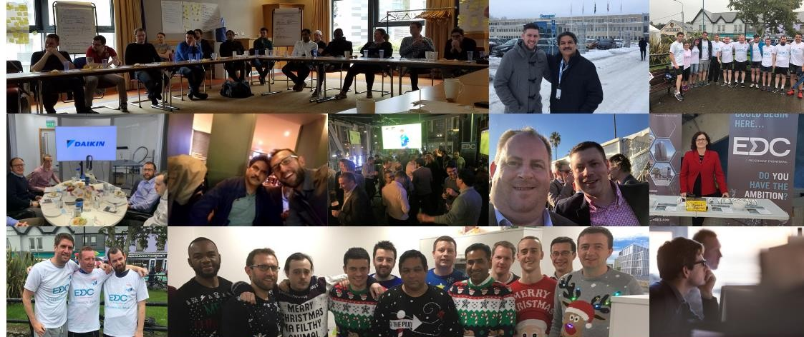

**OUR HIRING PROCESS**

**We know you live a busy life and so, we have adopted a hiring process that is targeted and streamlined. We focus on your fit with EDC as well as your technical skill match.**

**APPLY – REVIEW – INTERVIEW – OFFER - ONBOARDING**

**Apply:** Find an open role that interests you with EDC via one of our recruitment channels.

**Review:** Applications are read by real engineering managers who are both experts in interpreting resumes and are familiar with all EDC’s jobs within a talent segment—not just the one you applied for.

**Interview:** We use a competencies-based interviewing process that is intended to help us minimize unconscious bias while also making sure we hire people who will thrive within EDC.

**Offer:** We ensure we come back as quickly as possible with regards to whether you will be made an offer. If you verbally accept, we will send through an official written offer and begin the onboarding process.

FULL-TIME

PERMANENT

**BIM MANAGER**

**EMAIL**

**recruitment@edcengineers.com**

**WEBSITE**

**www.edcengineers.com**

**LOCATIONS**

**DUBLIN**

**4 Grand Canal Wharf,**

**South Dock Road,**

**Dublin 4, Ireland**

**CORK**

**River House, Blackpool Retail Pk.**

**Blackpool,**

**Cork, Ireland**

**MID-WEST**

**The Gallery,**

**13 Bedford Row Limerick,**

**V94 VY47**

**Limerick, Ireland**

**LONDON**

**Suite 2a, Westminster Tower,**

**3 Albert Embankment,**

**London, SE1 7SP, UK**

**PHONE**

**“OFFICE PHONE NUMBER”**